10. Implementation data types using Setter DI with XML configuration and ApplicationContext

What changed in Setter DI?
- ❌ <constructor-arg>
- ✅ <property name="...">
- Default constructor added
- Setter methods added
Feature | Constructor DI | Setter DI
Object creation | With arguments | Default constructor
Injection | During creation | After creation
Mandatory deps | ✔ Yes | ❌ No
Order matters | ✔ Yes | ❌ No
Best for | Immutable objects | Optional values

Constructor DI → “Everything at creation time”
Setter DI → “Create first, inject later”

If XML uses | DI Type
<constructor-arg> | Constructor DI
<property> | Setter DI

Spring Boot reality (Important)
In modern Spring Boot:
- Constructor DI is default
- Field injection is discouraged
- Setter DI is used selectively

Constructor DI is generally BETTER

Enforces mandatory dependencies
With constructor DI, an object cannot be created unless all required dependencies are provided.
public Student(Course course) {
this.course = course;
}

✔ Prevents partially-constructed objects
✔ Avoids NullPointerException
Setter DI cannot guarantee this by default.
Constructor DI allows Encourages immutability:
private final Course course;
✔ Safer
✔ Thread-friendly
✔ Easier reasoning
Setter DI cannot use final.
Constructor DI allows: Easier and cleaner unit testing
====================================================================

Create a Spring Boot Project

STEP-BY-STEP: Spring Core XML Project in STS
- File → New → Maven Project
- Click Next
- Search for “maven-archetype-quickstart”
- Click Next
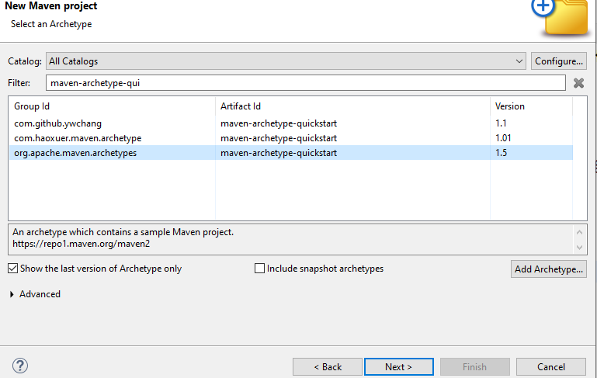

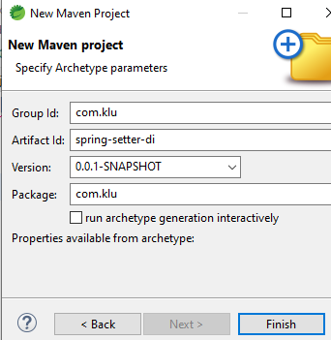
NOTE: Ensure the to “Uncheck” the checkbox: run archetype generationinteractively
Fill details:
Group Id : com.klu
Artifact Id : spring-setter-di
Packaging : jar
Package : com.klu

Click Finish
👉 Maven project is created.
Open pom.xml and add inside <dependencies>:
---------------------------------------------------------------------
<dependency>
<groupId>org.springframework</groupId>
<artifactId>spring-context</artifactId>
<version>5.3.30</version>
</dependency>
-------------------------------------------------------------------------
Wait until:
- Maven downloads jars
Project Structure
Create the following project structure
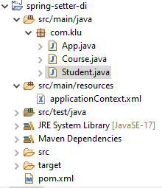
Create two classes (Course, Student) and
create a folder “resources” under src/main, inside this crate a applicationContext.xml file as shown above.

Create Non-Primitive Class (Course.java)

Course.java
-----------------------------------------------------------------
package com.klu;

public class Course {

private String courseName;
private int duration;

public Course() {
}

public void setCourseName(String courseName) {
this.courseName = courseName;
}

public void setDuration(int duration) {
this.duration = duration;
}

public String getCourseName() {
return courseName;
}

public int getDuration() {
return duration;
}
}
----------------------------------------------------------------------------------

Create Bean with Primitive + Non-Primitive (Student.java)

Student.java
--------------------------------------------------------
package com.klu;

import java.util.List;
import java.util.Map;
import java.util.Set;

public class Student {

// Primitive types
private int id;
private double fee;
private boolean active;

// Wrapper classes
private Integer age;
private Double marks;

// String
private String name;

// Array
private String[] skills;

// Collections
private List<String> subjects;
private Set<String> hobbies;
private Map<String, Integer> semesterMarks;

// Non-primitive
private Course course;

//Default constructor (MANDATORY for Setter DI)
public Student() {
System.out.println("Student object created");
}

//Setter methods (Injection happens here)
public void setId(int id) {
this.id = id;
}

public void setName(String name) {
this.name = name;
}

public void setFee(double fee) {
this.fee = fee;
}

public void setActive(boolean active) {
this.active = active;
}

public void setAge(Integer age) {
this.age = age;
}

public void setMarks(Double marks) {
this.marks = marks;
}

public void setSkills(String[] skills) {
this.skills = skills;
}

public void setSubjects(List<String> subjects) {
this.subjects = subjects;
}

public void setHobbies(Set<String> hobbies) {
this.hobbies = hobbies;
}

public void setSemesterMarks(Map<String, Integer> semesterMarks) {
this.semesterMarks = semesterMarks;
}

public void setCourse(Course course) {
this.course = course;
}

public void display() {
System.out.println("ID : " + id);
System.out.println("Name : " + name);
System.out.println("Fee : " + fee);
System.out.println("Active : " + active);
System.out.println("Age : " + age);
System.out.println("Marks : " + marks);

System.out.println("Skills:");
for (String s : skills) {
System.out.println(" - " + s);
}

System.out.println("Subjects : " + subjects);
System.out.println("Hobbies : " + hobbies);
System.out.println("Semester Marks: " + semesterMarks);

System.out.println("Course : " +
course.getCourseName() + " (" + course.getDuration() + " months)");
}
}
-----------------------------------------------------------------

Create XML Configuration File (applicationContext.xml) in the following folder. (Setter Injection)
Location: src/main/resources
------------------------------------------------------------------
<beans xmlns="http://www.springframework.org/schema/beans"
xmlns:xsi="http://www.w3.org/2001/XMLSchema-instance"
xsi:schemaLocation="
http://www.springframework.org/schema/beans
https://www.springframework.org/schema/beans/spring-beans.xsd">

<!-- Course Bean -->
<bean id="course" class="com.klu.Course">
<property name="courseName" value="Spring Framework"/>
<property name="duration" value="6"/>
</bean>

<!-- Student Bean -->
<bean id="student" class="com.klu.Student">

<!-- Primitive + Wrapper + String -->
<property name="id" value="101"/>
<property name="name" value="Rama"/>
<property name="fee" value="25000"/>
<property name="active" value="true"/>
<property name="age" value="22"/>
<property name="marks" value="89.5"/>

<!-- Array -->
<property name="skills">
<list>
<value>Java</value>
<value>Spring</value>
<value>Hibernate</value>
</list>
</property>

<!-- List -->
<property name="subjects">
<list>
<value>Maths</value>
<value>Physics</value>
<value>Computer Science</value>
</list>
</property>

<!-- Set -->
<property name="hobbies">
<set>
<value>Reading</value>
<value>Coding</value>
<value>Music</value>
</set>
</property>

<!-- Map -->
<property name="semesterMarks">
<map>
<entry key="Sem1" value="85"/>
<entry key="Sem2" value="88"/>
<entry key="Sem3" value="90"/>
</map>
</property>

<!-- Non-Primitive -->
<property name="course" ref="course"/>

</bean>

</beans>
----------------------------------------------------------

Copy the following code in the App.java Class (ApplicationContext IoC)

package com.klu;

import org.springframework.context.ApplicationContext;
import org.springframework.context.support.ClassPathXmlApplicationContext;

public class App {

public static void main(String[] args) {

ApplicationContext context =
new ClassPathXmlApplicationContext("applicationContext.xml");

Student student = context.getBean("student", Student.class);
student.display();
}
}
--------------------------------------------------------------------------------------------------------

Run the Application
- Right-click App.java
- Run As → Java Application
=================
OUTPUT
================
ID : 101
Name : Rama
Fee : 25000.0
Active : true
Age : 22
Marks : 89.5
Skills:
- Java
- Spring
- Hibernate
Subjects : [Maths, Physics, Computer Science]
Hobbies : [Reading, Coding, Music]
Semester Marks: {Sem1=85, Sem2=88, Sem3=90}
Course : Spring Framework (6 months)

If you not get error:
• Right-click project
• Maven → Update Project
- ✔ Force Update of Snapshots/Releases
- Click OK

Execution Flow
- JVM starts MainApp
- Spring loads applicationContext.xml
- Spring creates Course object
- Spring creates Student object
- Setter DI injects:
  - primitives (id, name, …)
  - non-primitive (Course)
- Bean returned using getBean()
- Business logic executed

WHAT SPRING ACTUALLY DOES (INTERNALLY)

In applicationContext.xml (Spring side)
Example:
<bean id="student" class="com.klu.Student">
<property name="id" value="101"/>
<property name="name" value="Rama"/>
<property name="course" ref="course"/>
</bean>
👉 <property> tells Spring: “Call the setter method for this field.”

Setter Injection
Spring reads XML and calls setters one by one:
course.setCourseName("Spring Framework");
course.setDuration(6);

student.setId(101);
student.setName("Rama");
student.setFee(25000);
student.setActive(true);
student.setAge(22);
student.setMarks(89.5);

student.setSkills(new String[]{"Java","Spring","Hibernate"});
student.setSubjects(List.of("Maths","Physics","Computer Science"));
student.setHobbies(Set.of("Reading","Coding","Music"));
student.setSemesterMarks(Map.of("Sem1",85,"Sem2",88,"Sem3",90));

student.setCourse(course);
THIS sequence is Setter DI

